Period 2 Section A Let’s try/Let’s learn P14

Learning aims(学习目标)
1.复习单词或词组cleaned, washed, watched, stayed, cleaned my room, washed my clothes, stayed at home, watched TV。
2.四会句子：How was your weekend ?It was good ,thank you .What did you do ?
I stayed at home with your grandma .Did you do anything else?
3.三会单词：drank 、show .

Important &difficult points(重难点)
1.重点：掌握四会句子。
2.难点：掌握一般过去时的句式特点并能正确运用。
导学探究

Step1 : 预习温故（用时5分钟）
1. Go over the old words and phrases :
T : clean S：cleaned /cleaned my room T: watch S: watched/watch TV
T: stay S: stayed/stayed at home T：wash S: washed/washed my clothes
2.Free talk :
T: What do you do on the weekend ? S: I often clean my room/…
T: What did you do? S: I watched TV/....
3.Chant together.

Step 2. 新课内容展示（用时18分钟）
1、T：How are you today ? Ss:I’m fine,thanks.
板书: T:How was your weekend ？ Ss:It was good,thank you. (is 的过去式was，师生互答)
2、T:What do you often do on the weekend ? Ss:I often watch TV.

板书：T:What did you do last weekend?S: I stayed at home with your grandma.(教读)

3、(1)单词：drink –drank， drank是过去式，师带读，生跟读。引出喝茶 drink tea—drank tea . I drank tea last weekend .

（2）句子: T:出示Mike’s爷爷奶奶喝茶、看电视的图片，

What did they do ?引导学生答：They drank tea and watched TV，师板书并教读：

We drank tea in the afternoon and watched TV。

4、板书呈现：show，children’s show，I watched some children’s show on TV.学生说意思，板书并教读。

5、T:What did you do last weekend ? S:I watched TV/….

T：Did you do anything else? Did you play football ?Did you do your homework ?...板书：Did you do anything else?学生说说意思并带读。

6、学生小组阅读对话并回答问题。(1)What did mike’s grandpa do lastweekend ? (2)What did mike do ？

7、学生讲解对话，教师补充答疑。

8、Listen to the tape of Let’s talk and follow it.

Step 3. 合作交流，师生共建（用时7分钟）
1.教读对话，分角色朗读。
2.学生灵活运用本课时单词、词组编对话。
Eg:I washed my colthes/….
3. Listen to the tape and finish Let’s try .

Step 4. 达标检测（用时9分钟）
一、读一读，选一选。
（ ）1.How was your weekend ? A.我们喝了下午茶还看了电视。
（ ）2. How are you ? B.你还做了其他什么事吗？
（ ）3.I stayed at home with your grandma. C.你周末过得怎么样？
（ ）4.We drank tea in the afternoon and watched TV. D. 你好吗？
（ ）5.Did you do anything else ? E.我和你奶奶在家里。
二、填一填，读一读，译一译
1.What ____（do/did）you do last weekend ？
2.I _______ (stay/stayed)at home with my mother yesterday.
3.How ____ (is/was) your weekend ?
4.Did you do ____(anything/any)else ?
5.We ______(drink/drank)tea last Sunday.
三．看图片，选句子。
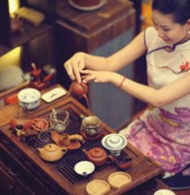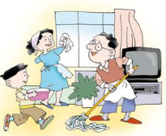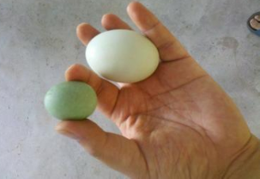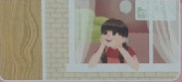
1._____ 2._____ 3._____ 4._____ 5._____
A．Mike cleaned his room last Sunday. B.Yao Ming is taller and stronger the man.
C.This egg is bigger than that one. D.I drank tea in the afternoon. E.Chen Jie stayed at home yesterday .
学生小结：这节课我学到了__________________________________

Step 5.布置课后作业（用时1分钟)
- 正确的格式抄写句子，并写出中文意思。
- 熟读P14Let’s talk.
Step6:板书设计
Unit 2 Last weekend
Words: drink ---drank show
Sentences: ---I stayed at home with your grandma .
---We drank tea in the afternoon and watched TV.
---Did you do anything else?
教学反思：

